Bulk Upload Process for Health Facility Registry (HFR) Via Admin Portal
What is Bulk Upload via Admin Portal
Bulk upload is a feature in the National Healthcare Providers Registry (NHPR) under the Ayushman Bharat Digital Mission (ABDM) that allows the District Nodal Officer (DNO) and State Mission Director (SMD) to register multiple healthcare facilities at once, and to assign multiple facilities to facility managers by uploading their details in a predefined format. This feature is especially useful for organizations, state health departments, or administrators managing a large number of facilities, as it saves time and ensures consistency in data entry.

Overview of the facilities bulk upload process by ADMIN (SMD/DNO)
- Template-Based Upload
Users must download the predefined template from the NHPR portal. The template includes all required fields such as facility manager Aadhar details, facility name, address, type, ownership, and other details.
  - Template for Hospital/Clinic/CHC/PHC/SC/HWC/College -
  - Diagnostic Laboratory and Imaging Centre-
  - Pharmacy-
  - Blood Bank-

- Data Entry
Fill in the details of all the facilities in the template. It is essential to adhere to the specified format and mandatory fields to avoid errors during the upload.
User can either fill the prospective facility manager Aadhar details or user can fill the prospective facility manager HPID/HPID number.

- Validation
The system validates the uploaded file for completeness and correctness. Any discrepancies, such as missing mandatory fields or incorrect Aadhar details, are flagged for correction.
Facility manager can only have 10 facilities registered, if user try to upload more than 10 facilities, system will upload up to 10 facilities and provide error log for the remaining facilities. If the user already has 10 facilities registered, system won’t allow any new facility to be registered for the user.

- Upload Confirmation
After successful validation, the system processes the upload and adds the facilities to the registry. Users can download the report showing the status of each record (success or error). System will provide HPID of the facility managers and facility id of the onboarded facilities.

- Error Handling
If some entries fail validation, users can download an error report, correct the issues, and re-upload the file.

- Selection of the HPID Role for bulk upload of the facilities

- The facility manager (HPID/HPID no.) cannot have the verifiers function.

- On the HPID profile screen, the HPID should have selected either role no.2 (I am a Facility Manager/Administrator) or role no.3 (I am Healthcare Professional & Facility Manager). For the bulk upload, the role number 1 of the healthcare professional is not allowed for any HPID.

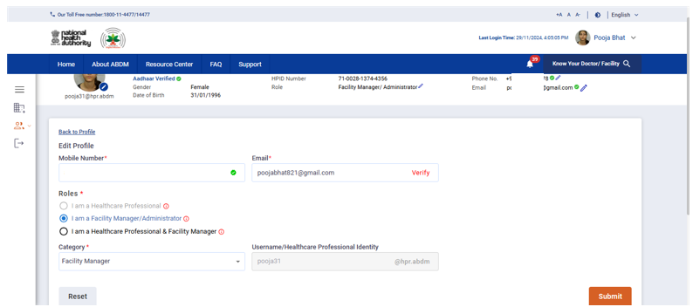
- Status

Admin can register the facility in two statuses
- Submitted- Facilities will be registered in submitted state and will be verified by the district verifiers.
- Approved- Facilities will be registered in approved state and further verification is required.
Steps for bulk upload of facilities by ADMIN (SMD/DNO)
Step 1: Log in to the portal by Admin’s credentials.

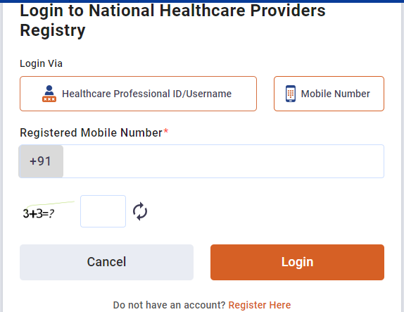

Step 2: Click on the three horizontal lines “Hamburger Menu”, click on “Master Management”, then select “Add facilities in bulk”.
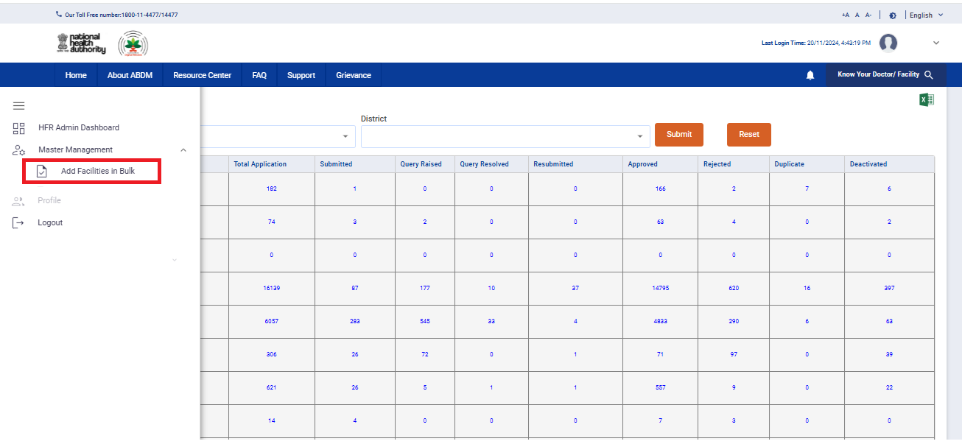

Step 3: Click on “Add Bulk facility”.
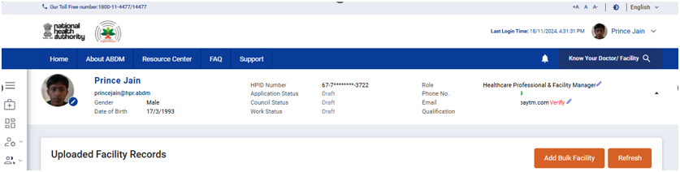

Step 4: Select the type of facility from the drop down and then click on “Download Template” button
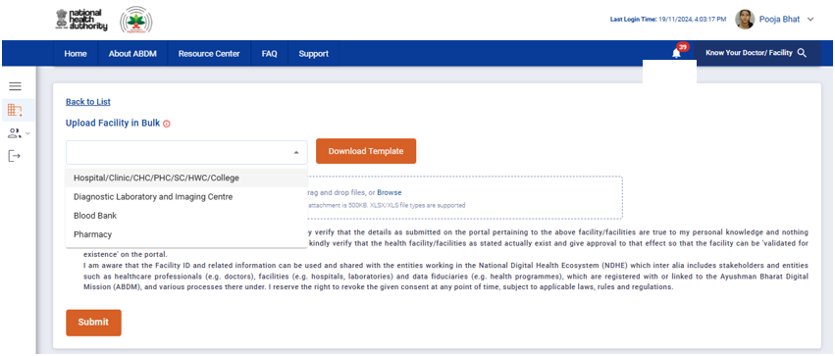

Step 5: Open the downloaded template and read the instructions carefully.
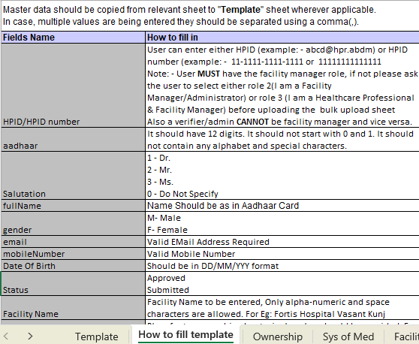
Step 6: After carefully going through the instructions, fill the sheet accordingly.
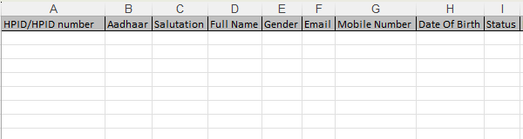

Note: Only up to 10 facilities can be assigned to a single facility manager (Aadhar/HPID/HPID number).
Step 7: Upload the filled sheet. The file should not be more than 500 KB.
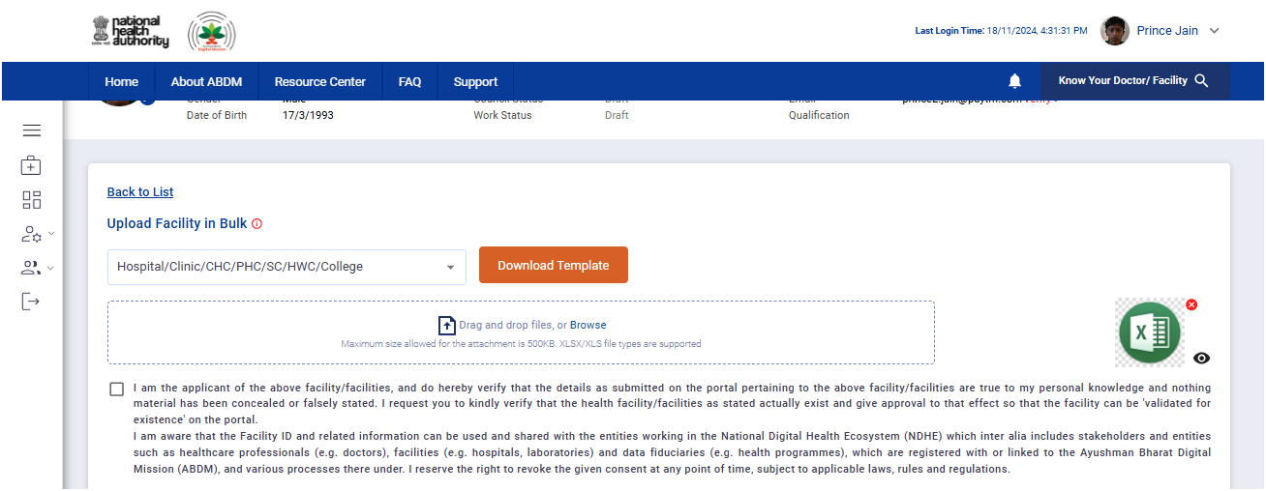
Step 8: Tick the check box and click on Submit button.
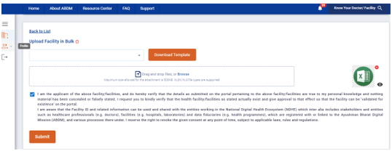

Step 9: In a single bulk upload, three cases can be seen
- All facilities are successfully uploaded.
- All facilities are failed.
- Some are successfully onboarded while others are failed.
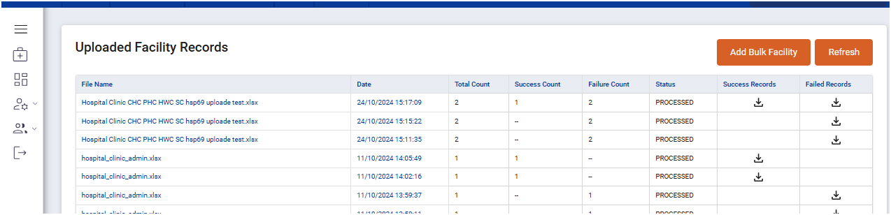

Step 10: If the facility upload is failed, then user can download the failed record sheet to see the error of failure.

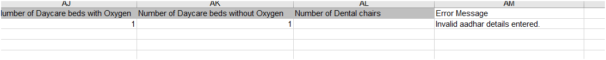

Step 11: Correct the error and upload the corrected sheet again.
Step 12: Registered facilities will be visible on the facility manager dashboard.
